**Assignment 1**

• Install Power BI Desktop and share the final screenshot of the report view page which appears when power desktop starts.

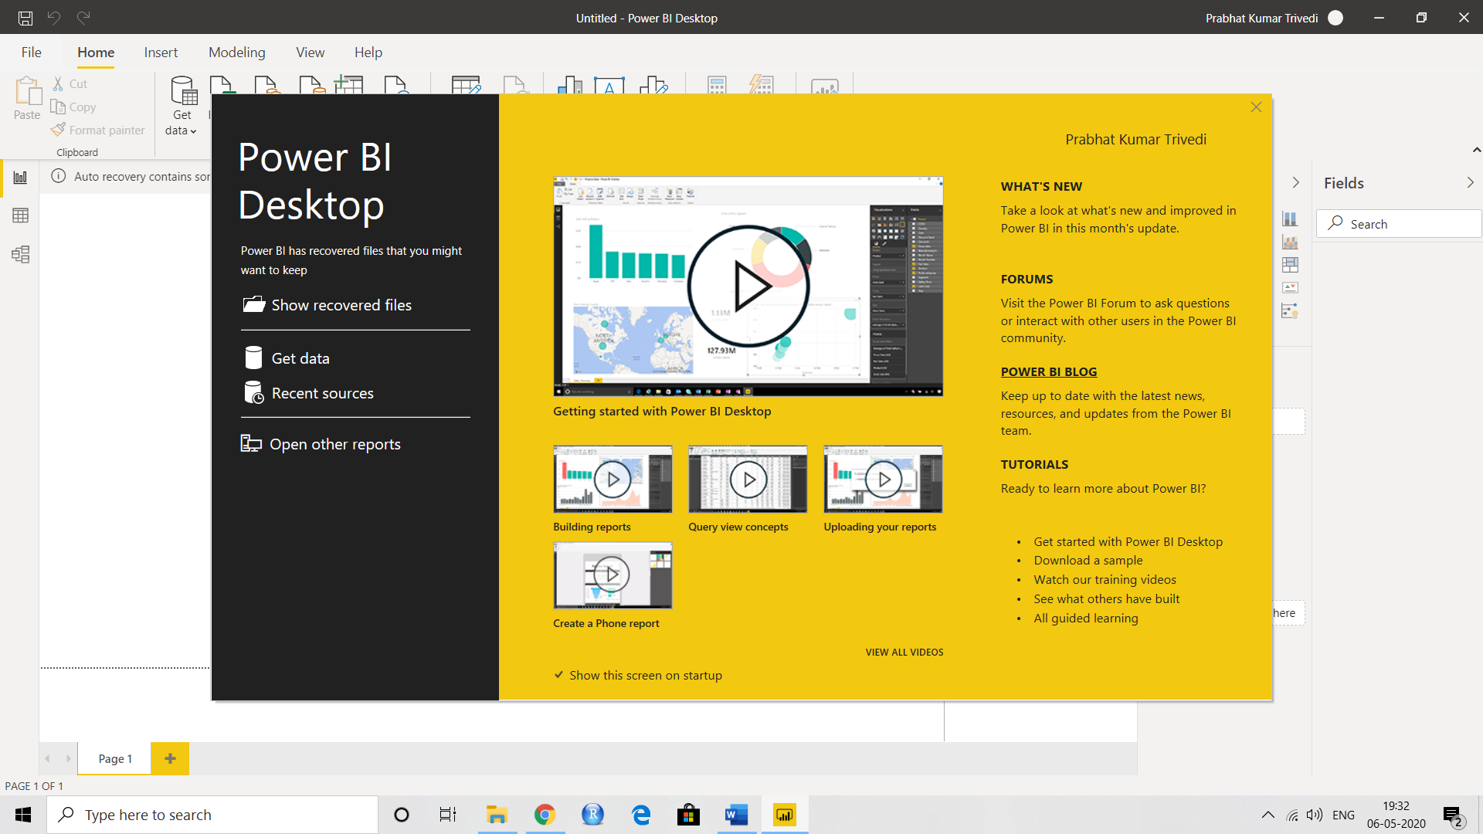

Report View

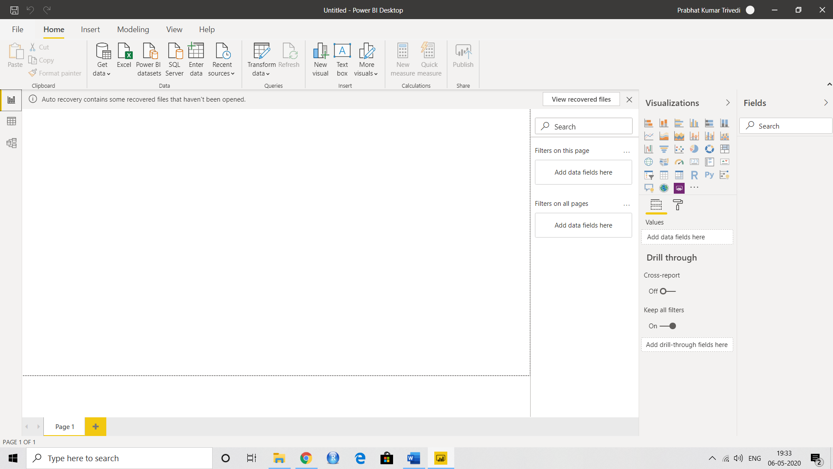

Data View

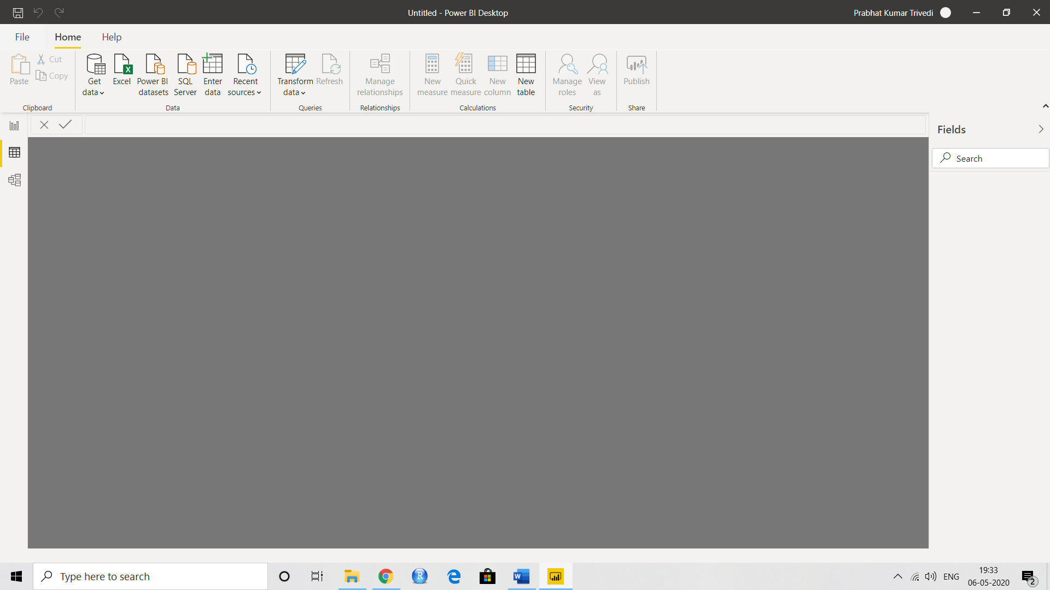

Model View

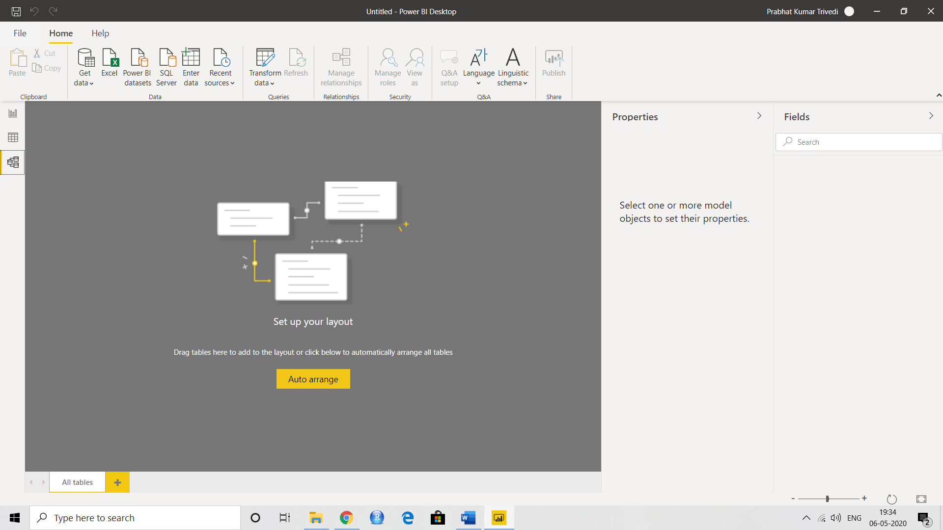

Power Query Editor

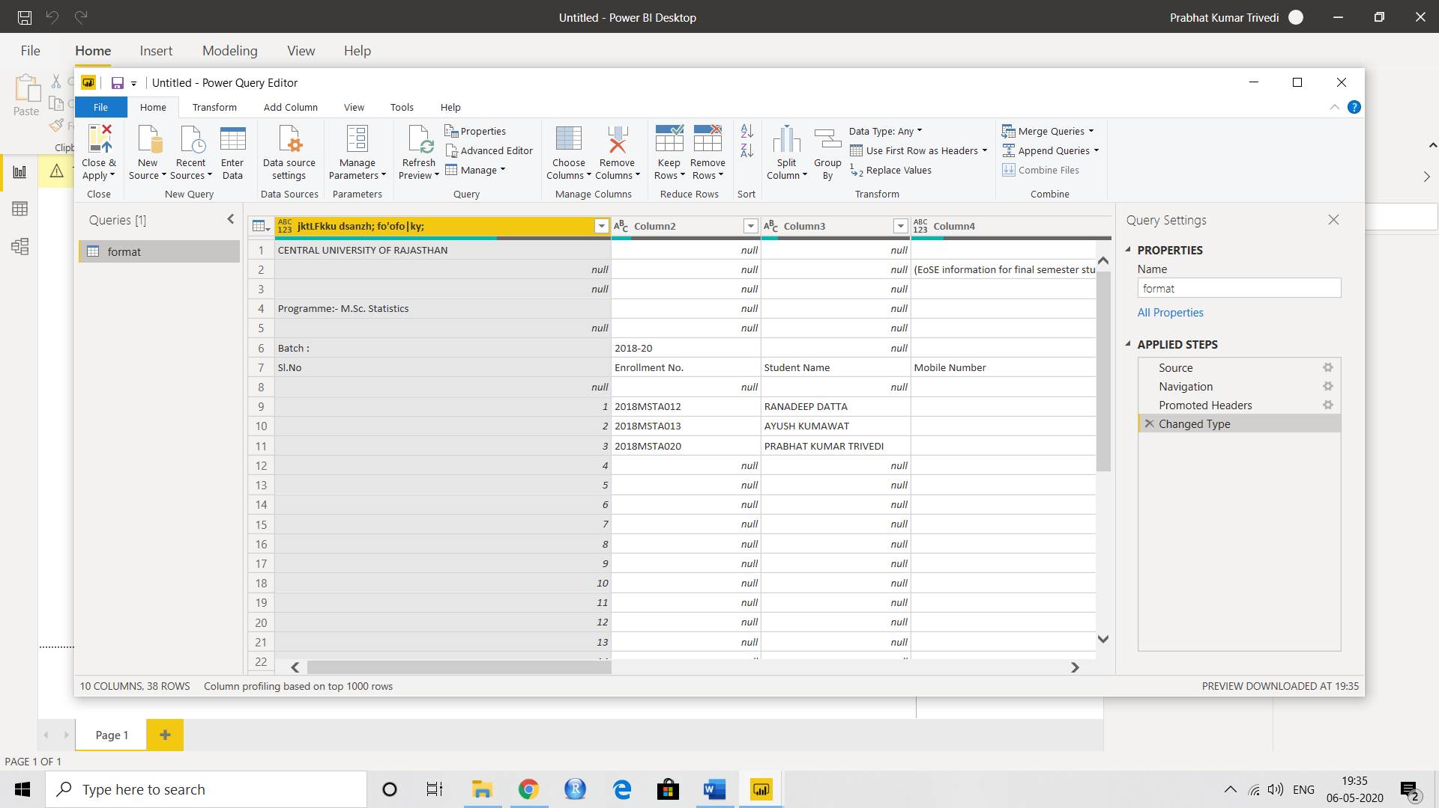

Advance Editor

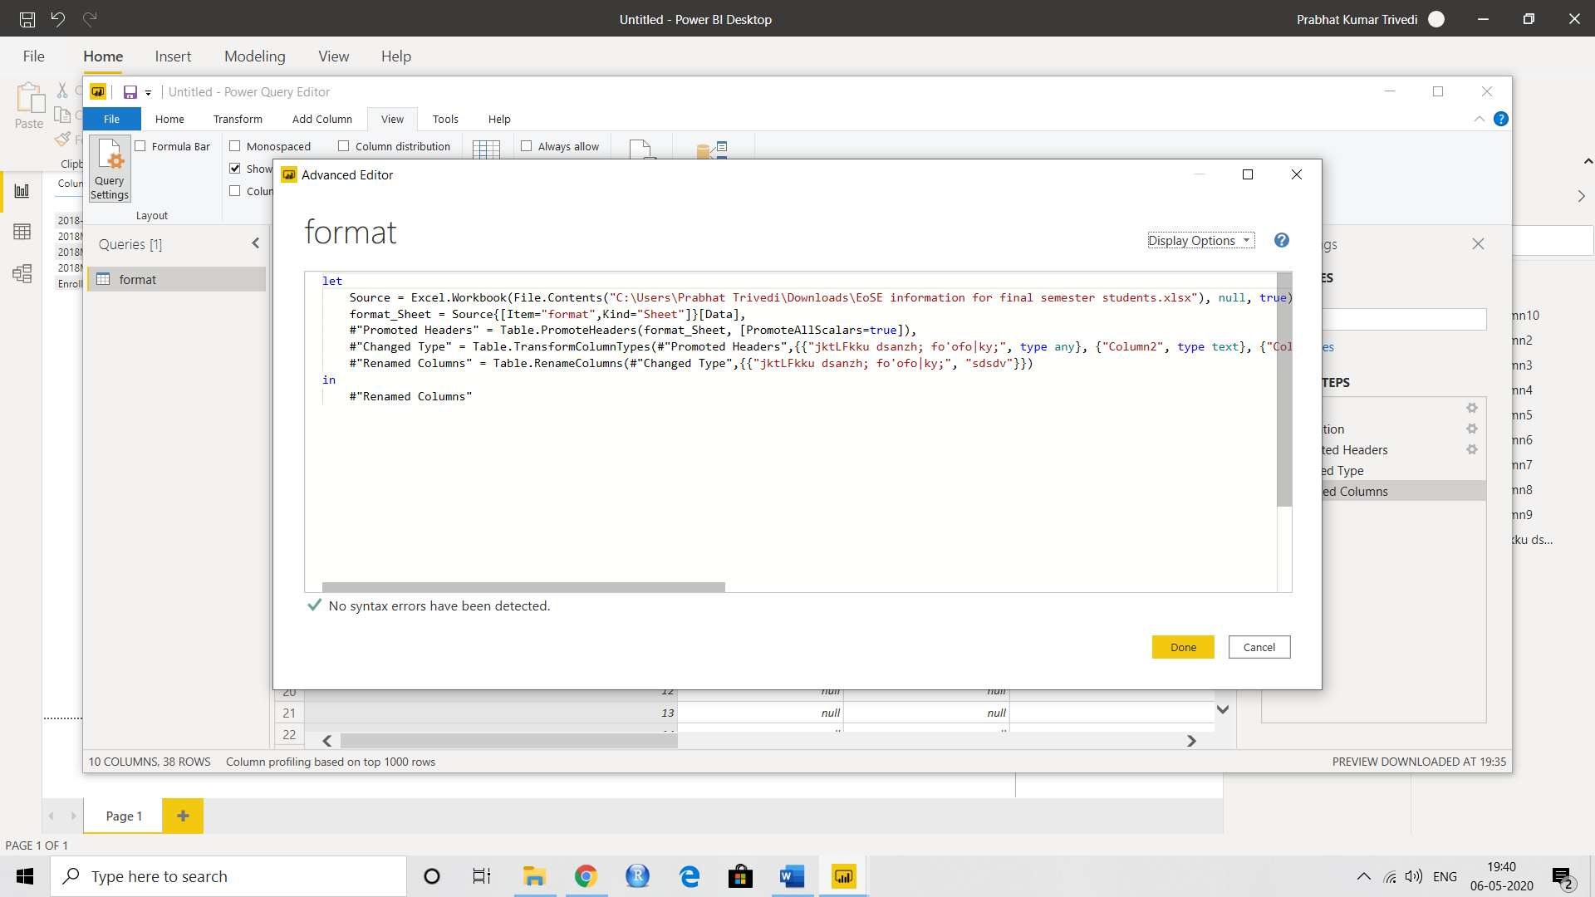

* Prepare a document with details of the following along with their price − Power BI Desktop − Power BI Pro − Power BI Premium

|  |  |  |
| --- | --- | --- |
| Power BI Desktop | Power BI Pro | Power BI Premium |
| * Power BI is a cloud-based business analytics service that gives you a single view of your most critical business data. * Monitor the health of your business using a live dashboard, create rich interactive reports with Power BI Desktop * Price - Free | * Self-service and modern BI in the cloud * Collaboration, publishing, sharing, and ad-hoc analysis * Fully managed by Microsoft. * Price- ₹660.00   Monthly price per user | * Enterprise BI, big data analytics, cloud and on-premises reporting * Advanced administration and deployment controls * Dedicated cloud compute and storage resources * Allows any user to consume Power BI content * Price - ₹330,190   Monthly price per dedicated cloud compute and storage resource with annual subscription |